**FPT ACADEMY INTERNATIONAL**



## FPT – APTECH COMPUTER EDUCATION

Fun-Zone

|  |  |  |  |
| --- | --- | --- | --- |
| **Center Name** | | FPT – Aptech – HCM2  Address: 590 Cach Mang Thang Tam, District 3, Ho Chi Minh City | |
| **Instructor** |  | Ms. Le Mong Thuy |  |
| **Class** |  | T1.2104.E0 |  |
| **Group** |  | 1 |  |
| **Group members** | | **Name** | **Student ID** |
|  |  | Nguyễn Quốc Khang | Student1313770 |
|  |  | Đinh Toàn Thịnh | Student1316192 |
|  |  | Bùi Nguyễn Trọng Nhân | Student1316189 |
| **Duration** | Start date | 14-Jul-2021 |  |
| End date | 14-Aug-2021 |  |

**This is to certify that**

**Mr.:**

Nguyễn Quốc Khang

Đinh Toàn Thịnh

Bùi Nguyễn Trọng Nhân

**has successfully designed & developed**

eProject: FUN-ZONE

**Submitted by:**

Nguyễn Quốc Khang

**Date of issue:**

**Authorized Signature:**



**TABLE OF CONTENTS**

FPT – APTECH COMPUTER EDUCATION 1

ACKNOWLEGMENT 3

SYNOSIS 3

PROBLEM DEFINITION 4

CUSTOMER'S REQUIREMENTS SPECIFICATIONS (CRS) 5

Business/Project Objective: 5

Hardware/ Software Requirements: 6

SCOPE OF THE WORK (IN BRIEF) 7

Architecture and design of the system 8

Diagram of the website 9

TASK SHEET REVIEW 1 10

SITE MAP 12

MOCK OF THE WEBSITE 13

1. ***Homepage*** ***13***

***2. EXPERIENCE*** ***14***

***3. Leisure &Dinning*** ***15***

***4.1 hightech land section*** ***16***

***4.2-4.8 7 wonder-Park section*** ***17***

***5. Whats Up*** ***18***

***6. Contact us+business opportunities*** ***19***

***7. About us*** ***20***

***8.***

**9.**

**10.**

TASK SHEET REVIEW 2 21

WEBSITE DESCRIPTION

***1. EXPERIENCE*** ***22***

***2. What Up*** ***23-24***

***3. 7 wonder Park Characters*** ***25-26***

***4. Hightech land*** ***27-28***

***5. Home page*** ***29-30***

***6. Leisure &Dinning*** ***31-32***

***7. Contact us Business opportunities*** ***33-34***

***8. About us*** ***35***

**9.** Menu&footer 36

**10.** Java Script 37-42

TASK SHEET REVIEW 3 43

# ACKNOWLEGMENT

On behalf of all the members of group 1, I would like to thank you all for the hard works, supports to make this eProject complete successfully. Especially, Ms. Le Mong Thuy, our teacher, she helped us a lot from the day that we started to study at FPT Aptech. With this eProject, she has guided us with her enthusiasm and rigorous, because of her guiding, we would be able to finish this project. Besides, I want to thank all the team member of group 1, each of the team member has been working in order to complete this project. The last but not least, we would like to say thank you to our family for always supporting us, creating the best conditions for us to focus on the project, and putting faith in the dreams we pursue.

# SYNOSIS

The ‘FUN ZONE’ Most Entertaining Theme Park, is one of the best ideas executed in the amusement & entertainment industry. It caters to everyone, be it a child who seeks entertainment or an adult who wishes for a pleasant evening. This initiative is aimed towards providing its visitors with ample elements to spend a quality day. It promises fun and frolic packed with adventurous and elegant ambience.

It has 7 different internationally themed zones which will keep you occupied for the entire day. You will never fall short of excitement or thrills, thanks to the mascots that will make sure you are treated with the best of hospitality. There are zones like thrill rides, 7 wonders of the world, a massive food court and other areas ensuring 360 degrees of sheer entertainment.

.

# PROBLEM DEFINITION

The Web site is to be created based on the following requirements.

1. The Home Page should be created making use of Frames with a suitable logo
2. The site should display a menu with following categories:

* EXPERIENCE
* LEISURE & DINNING
* PARKS CHARACTERS
* WHATS UP
* PARK INFORMATION
* BUSINESS OPPORTUNITIES

1. ‘EXPERIENCE’ menu option should provide an overview of the entire park with proper maps and brief information on the sections in park.
2. ‘LEISURE & DINNING’ menu option should provide information on food section with outlet details. It can also be organized brand wise. When a user selects any particular brand, a list of products for that brand will be displayed
3. ‘PARKS CHARACTERS’ menu option should provide details about the characters in the parks and a small story should be associated to them.
4. ‘WHATS UP’ should provide details of past and upcoming events.
5. There should be a “Contact Us” page which will have the Address of the Company which is as follows and the mail address which when clicked will invoke the local mail client from where they can send an email. Address of the Company should be displayed using GeoLocation API (eg. GoogleMaps).

# CUSTOMER'S REQUIREMENTS SPECIFICATIONS (CRS)

**Client: Fun-Zone**

### Business/Project Objective:

Growing in popularity, the “FUN ZONE” has connected with thousands of families and has successfully entered the massive amusement & entertainment industry.

‘FUN ZONE’ is looking to have it’s own website to provide information and also connect with prospective clients.

The website is to be developed for the Windows Platform using HTML5, JavaScript and Geolocation. The site should work well in all leading browsers including Chrome, IE, Firefox etc.

**Input to the system:**

* Filter a list of products for that user selected in Leisure & Dinning page
* Leave comment to the ‘Fun-zone’ customer service.
* Send mail to the Fun-zone company in business opportunities page and mail to customer service in contact us page.

**Output from the system:**

* Displaying result of products for that user selected in Leisure & Dinning page
* Display the local mail client when user click to the mail address in Contact Us page.

**Process**:

* Show and short the picture in website.
* Show and sort timetable of some service in fun-zone.

**Expected delivery date:**

14-08-2021

**List of deliverables:**

* + - * Document Word.
      * User Guide.
      * Source code.

### Hardware/ Software Requirements:

**Hardware**

* A minimum computer system that will help you access all the tools in the courses is a Pentium 166 or better
* 64 Megabytes of RAM or better

**Software**

* Notepad/HTML editor
* Dreamweaver
* IE 5.0/ Netscape 6.0

# SCOPE OF THE WORK (IN BRIEF)

After a long and detailed discussion, our group has decided to create a website contain the following webpages:

1. ***Homepage***: Display information about newest-selling products, an introduction about fun-zone
2. ***EXPERIENCE:*** provide an overview of the entire park with proper maps and brief information on the sections in park.
3. ***LEISURE & DINNING:*** provide information on food section with outlet details
4. ***PARKS CHARACTERS:*** provide details about the characters in the parks and a small story should be associated to them
5. ***WHATS UP :*** should provide details of past and upcoming events.
6. ***Contact Us:*** Park information: address of the Company,email…

***6.1 :BUSINESS OPPORTUNITIES :*** document, advised for who want to apply for a job.

# Architecture and design of the system

Webpage request



Requested Page

**RENDERING**

**ENGINE**

**CSS CODE**

**HTML CODE**

**WEB SERVER**

**WEB BROWSER**

**CLIENT**

**SERVER**

# Diagram of the website

HomePage

EXPERIENCE

BUSINESS OPPORTUNITIES

CONTACT US

WHATS UP

PARKS CHARACTERS

LEISURE & DINNING



# TASK SHEET REVIEW 1

|  |  |  |  |  |  |  |  |
| --- | --- | --- | --- | --- | --- | --- | --- |
| **Project Ref. No.:**  **eP/Advertisement Portal Management**  **System/01** | | **Project Title:** | **Activity Plan Prepared By:** | **Date of Preparation of Activity Plan:** | | | |
| **Sr.**  **No.** | **Task** | **Actual**  **Start Date** | **Actual Days** | **Team**  **Mate Names** | **Status** |
| 1 | Problem Statement | FUN ZONE | Khang | 15-July-21 | 1 | Khang | Completed |
| 2 | Analysis requirements about the website | 15-July-21 | 1 | Thịnh | Completed |
| 3 | The scope of the work (in brief) | 15-July-21 | 1 | Khang | Completed |
| 4 | Architecture and design of the system | 15-July-21 | 1 | Khang+Thinh | Completed |
| 5 | Diagram of the website | 15-July-21 | 1 | Thịnh | Completed |
| 6 | Task Sheet | 15-July-21 | 1 | Khang | Completed |

|  |  |
| --- | --- |
| **Date: 16-07-2021** | |
| Signature of Instructor:  **Ms. Le Mong Thuy** | Signature of Team Leader:    **Nguyen Quốc Khang** |

# SITE MAP

HOME

Contact & CS page

Business opportunities

Great Wall China

page

About us page

Experience

Machu Picchu Peru

Chichen itze Mexico page

Tai Mahal India

Petra Jodan

Great Wall China

page

Christ The Redeemer Brazil

Colosseum Italy

What Up page

Leisure & dinning page

Experience page

Contact us

What Up

Leisure & Dinning

Park character

# MOCK OF THE WEBSITE

1. **Homepage**

LOGO – IMAGE WEBSITE

MENU

PICTURE

Offers and Benefits

Planning Guide

Event

Shopping,dinning,playing

CONTACT + INFORMATION FUNZONE

**2.Experience Page**

CONTACT + INFORMATION FUNZONE

List of section in Park and brief infomation

Map of the park

Information, overview about fun-zone park

IMG

MENU

LOGO – IMAGE WEBSITE

**3.** Leisure & dinning page

Footer

MENU

LOGO – IMAGE WEBSITE

List of img and information of product

Catalogues

PICTURE

**4.** hightechland park character page

CONTACT + INFORMATION FUNZONE

MENU

LOGO – IMAGE WEBSITE

PICTURE

PICTURE

PICTURE

* + - 1. 7 wonder-park character page

IMG + TEXT + LINK

IMG + TEXT

IMG + TEXT

IMG + TEXT

MOST SPECIAL SECTION

NAME

PIC OF CHARACTERS

CONTACT + INFORMATION FUNZONE

MENU

LOGO – IMAGE WEBSITE

**5.What Up Page**

ABOUT EVENT

PICTURE

ABOUT EVENT

PICTURE ABOUT EVENT

INFORMATION

ABOUT EVENT

PICTURE

ABOUT EVENT

INFORMATION ABOUT EVENT

PICTURE ABOUT EVENT

CONTACT + INFORMATION FUNZONE

MENU

LOGO – IMAGE WEBSITE

**6.Contact us +bussiness opportunities**

CONTACT + INFORMATION FUNZONE

MENU

LOGO – IMAGE WEBSITE

Tel,email..

address

Support Center  
& Customer comment

Google map, Address of Park

Information of Company  
Customer Service.

1. **About Us (team infomation)**

LOGO – IMAGE WEBSITE

Picture+info

CONTACT + INFORMATION FUNZONE

v

Thanks and some word about project

Picture+info

# TASK SHEET REVIEW 2

|  |  |  |  |  |  |  |  |
| --- | --- | --- | --- | --- | --- | --- | --- |
| **Project Ref. No.:**  **eP/Advertisement**  **Portal**  **Management System/01** | | **Project Title:** | **Activity Plan Prepared By:** | **Date of Preparation of Activity Plan:** | | | |
| **Sr.**  **No.** | **Task** | **Actual Start Date** | **Actual Days** | **Team Mate Names** | **Status** |
| 1 | Site map | Fun zone | Khang | 16-07-2021 | 1 | Khang | completed |
| 2 | Mock of the website | 16-07-2021 | 1 | Thịnh+  Khang | completed |
| 3 | Task sheet | 16-07-2021 | 1 | Khang | completed |

|  |  |
| --- | --- |
| **Date:17-07-2021** | |
| Signature of Instructor:  **Ms. Le Mong Thuy** | Signature of Team Leader:  **Nguyen Quoc Khang** |

# WEBSITE DESCRIPTION

**1.Experience Page**

1. Description

This webpage displays following information: Overview about Funzone Land, show proper map,  
list of Funzone-land’s section, picture and brief information of individual section.

1. Screenshoot

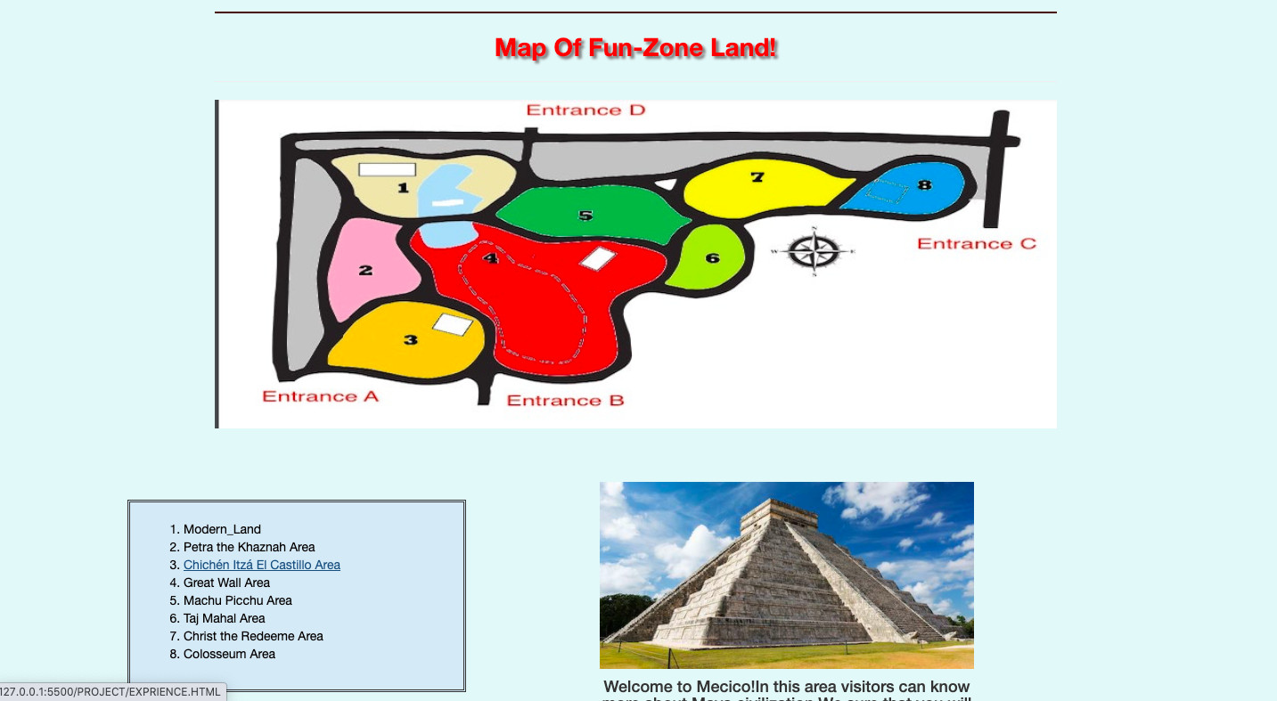

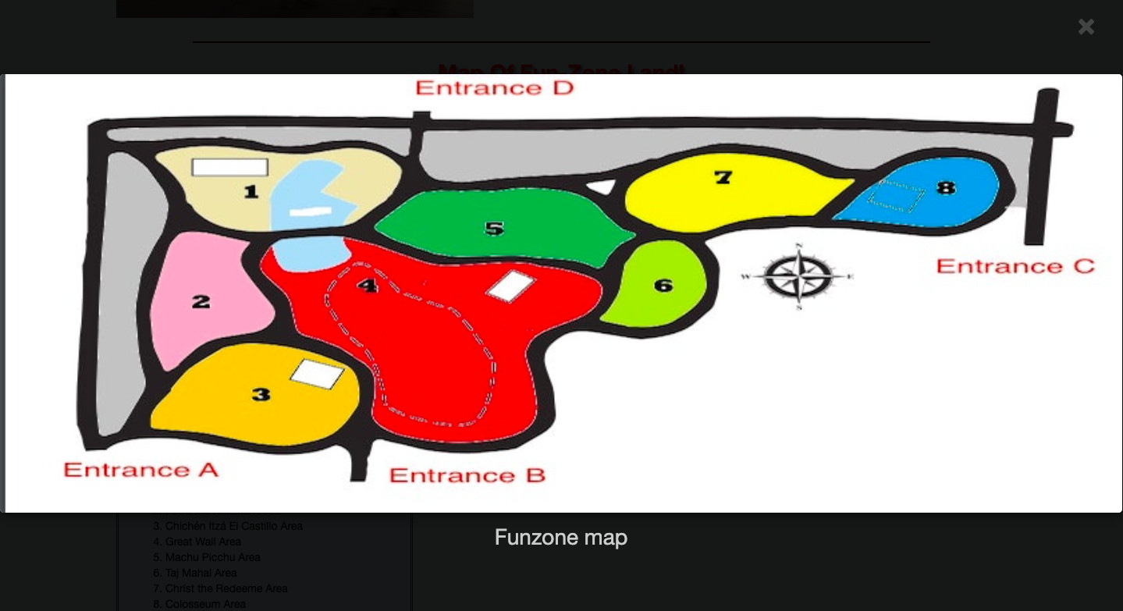

**2.What Up Page**

1. Description

This webpage displays following information: event of park in past and in future. Place, time, and introduce about event.

1. Screenshoot

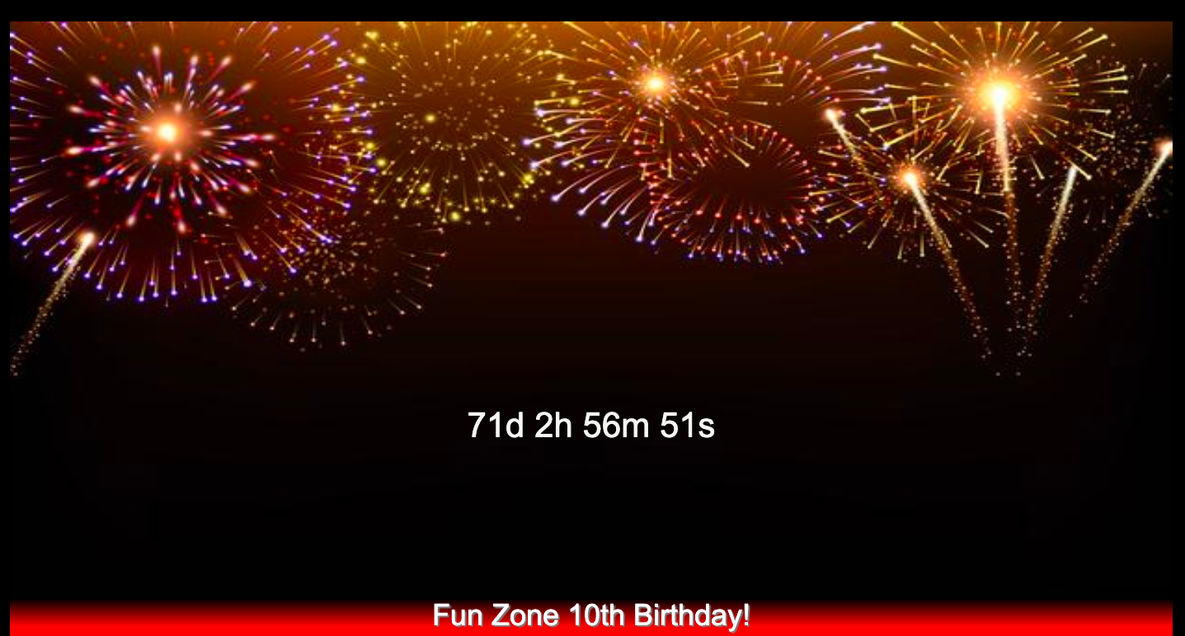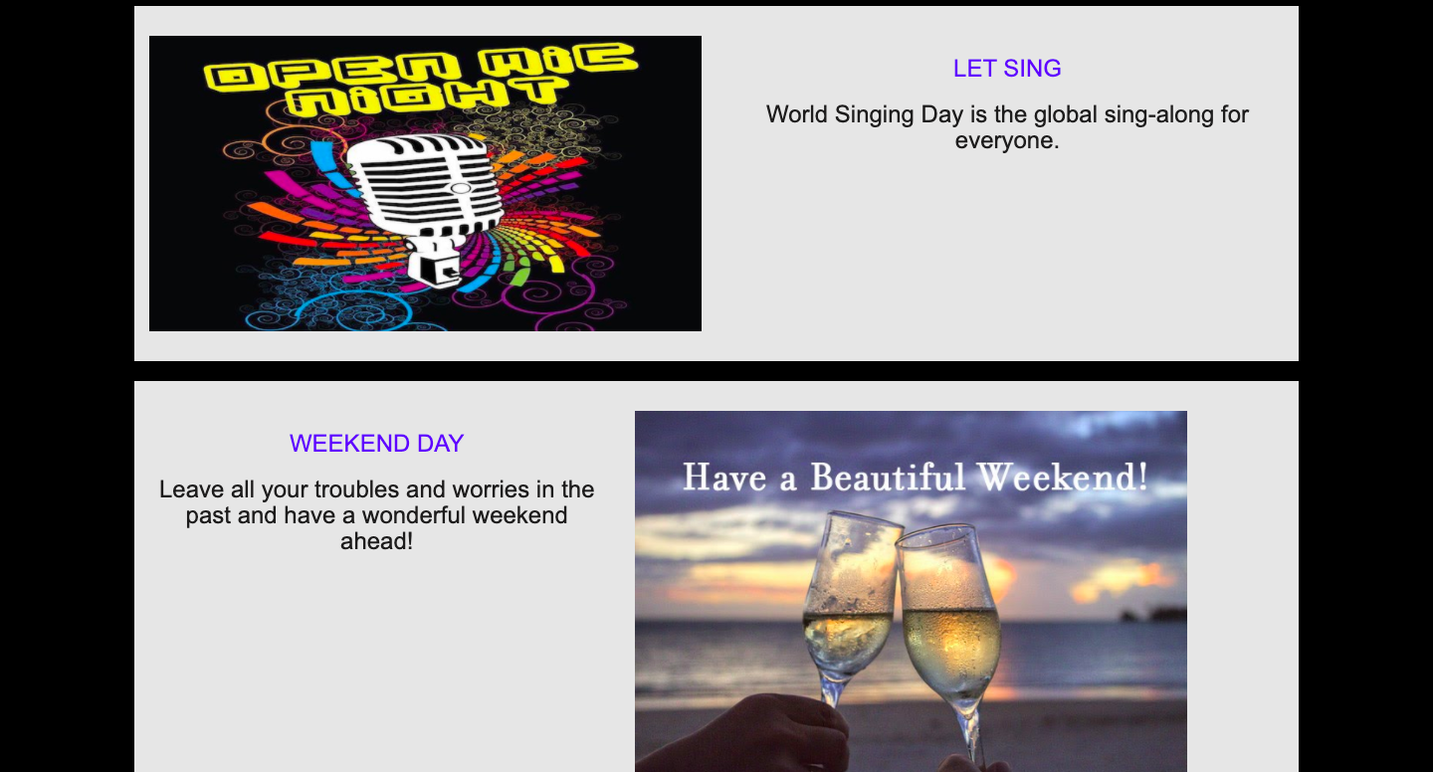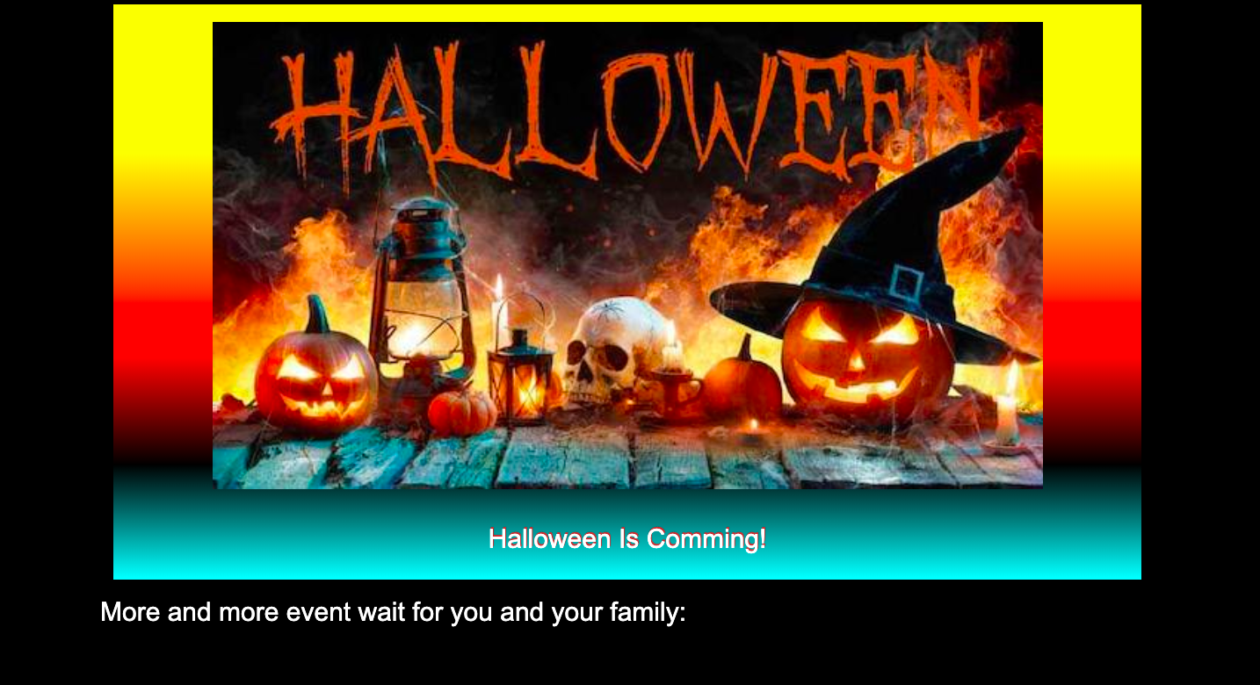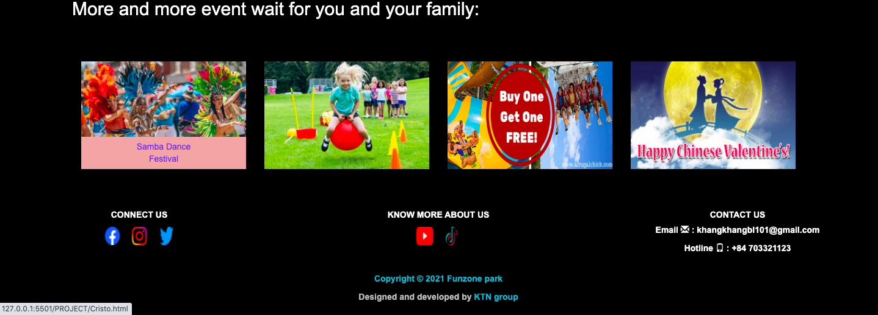

**3.Character page**

**3.1:7-wonder page (7 page):**

a.Description

This webpage displays following information: Overview about 7 wonder section in funzone Land.  
b.screenshot:

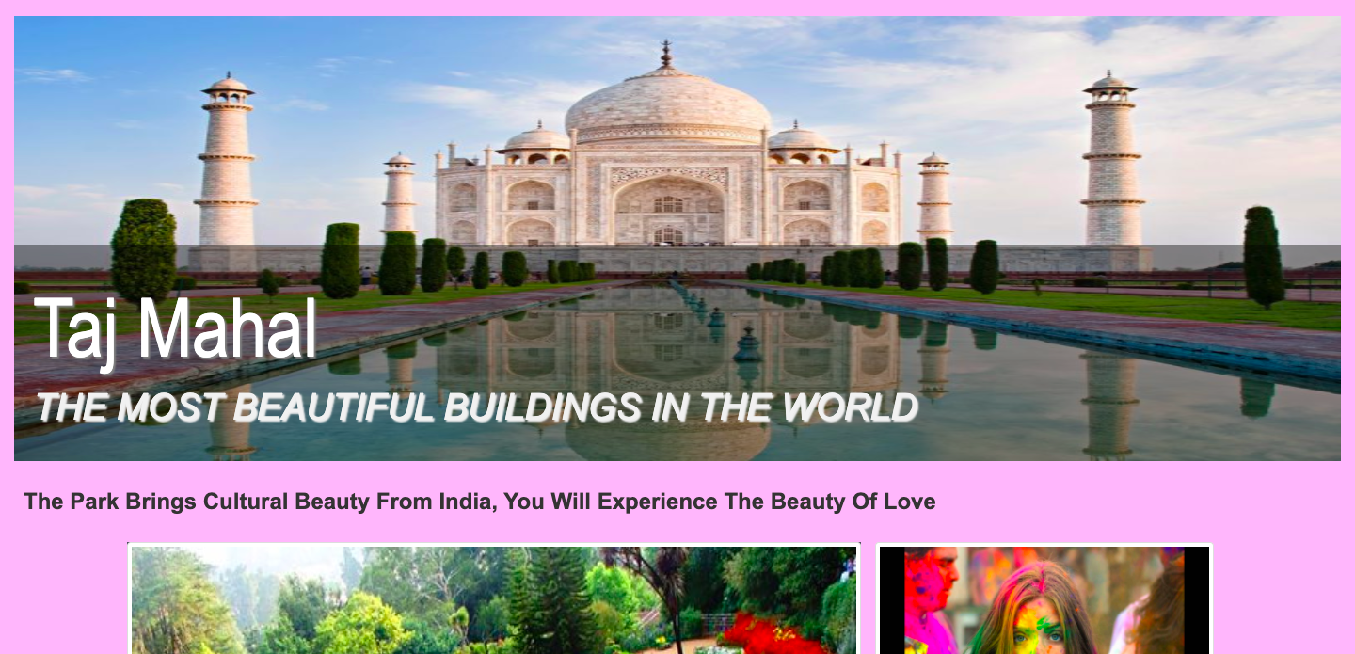

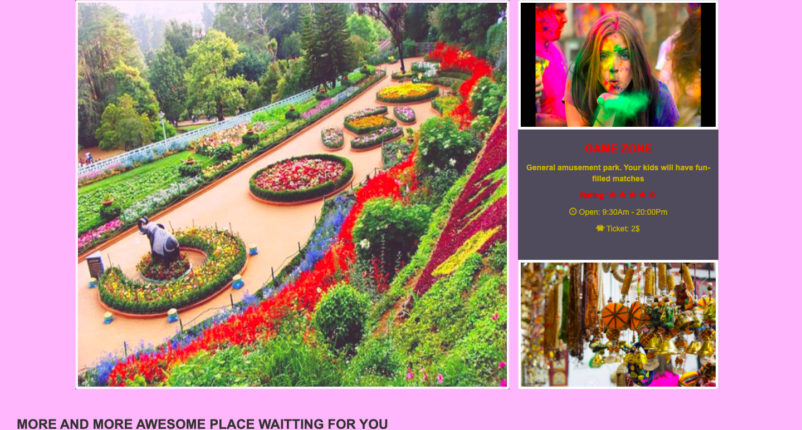

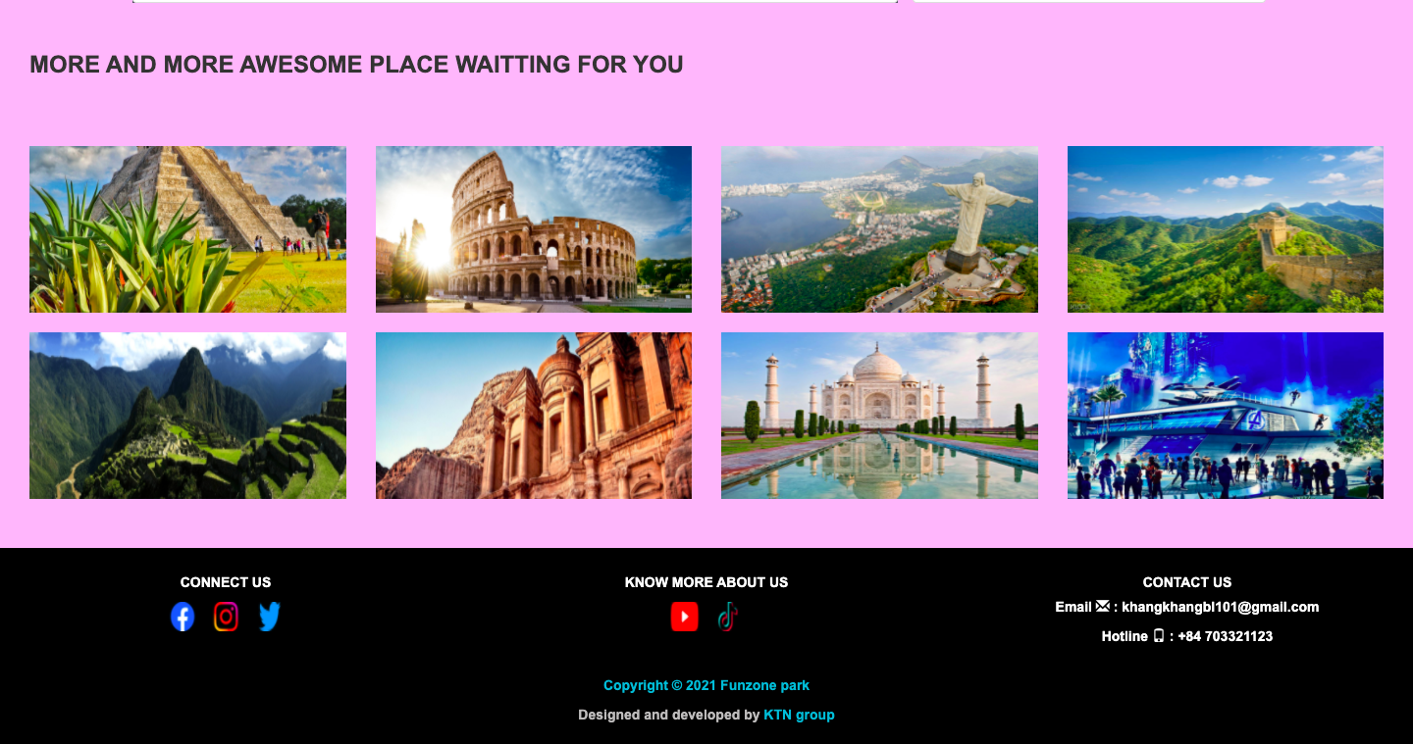

3.2:Hightech land page:

Description:This webpage displays following information: Overview about hightech land section in funzone Land.

Screen shot:

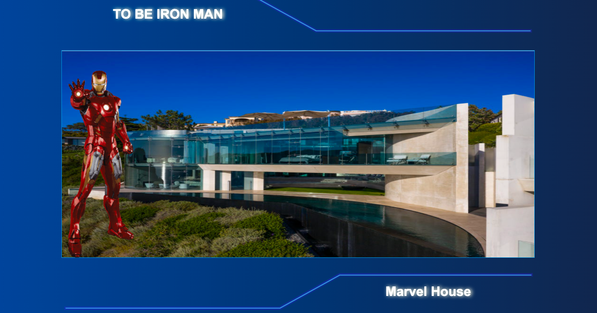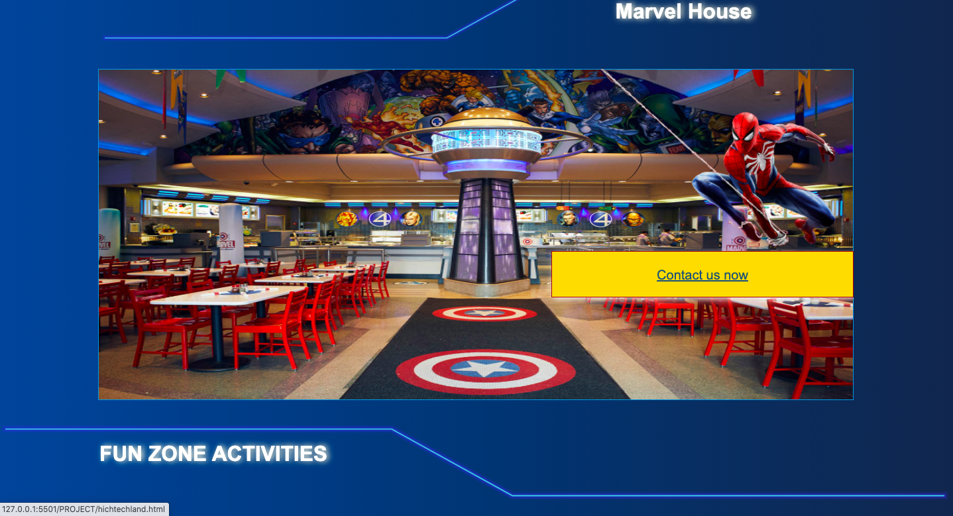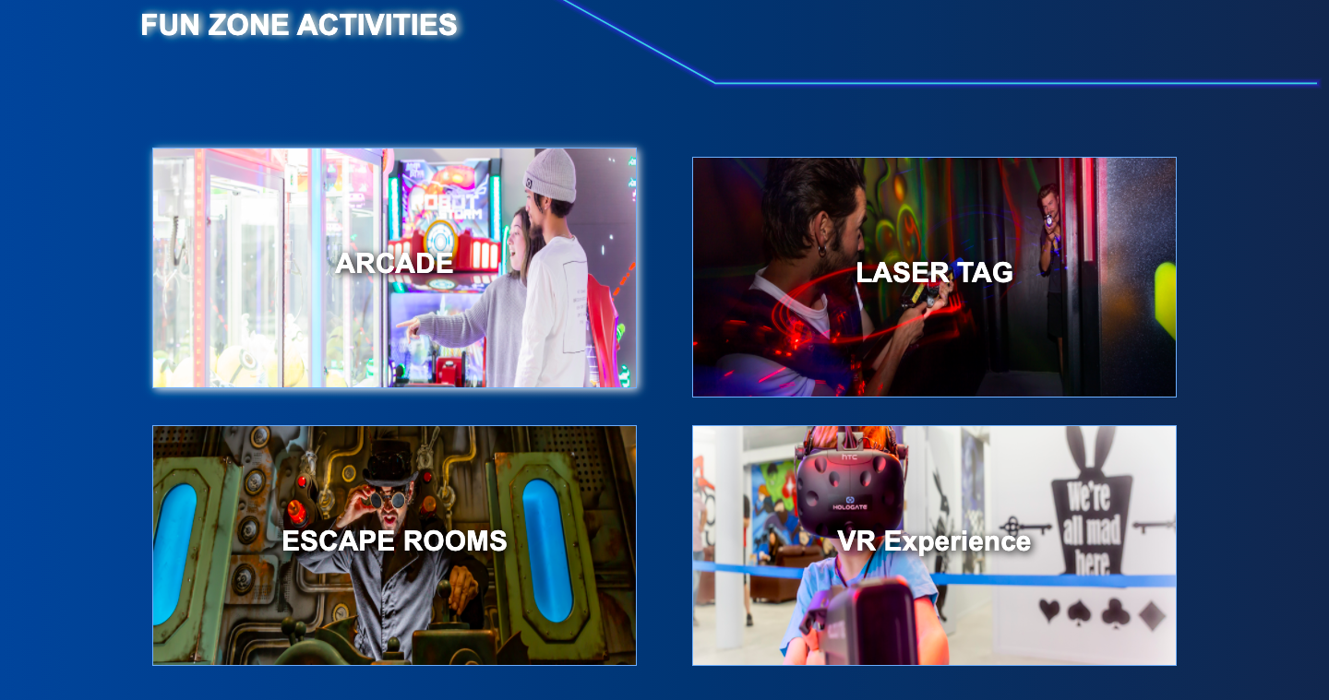

4.Home page:

Description:This webpage displays following information: Display about 7 wonder section, acctivities, short infomation about page in website

Screen shot:

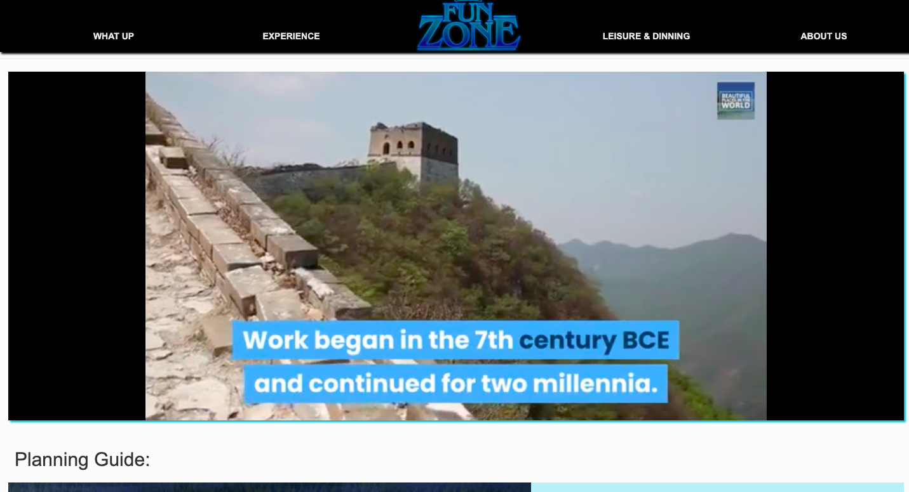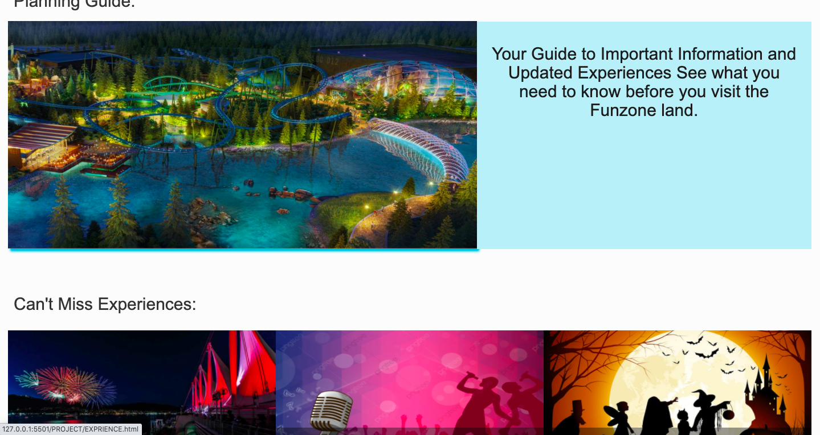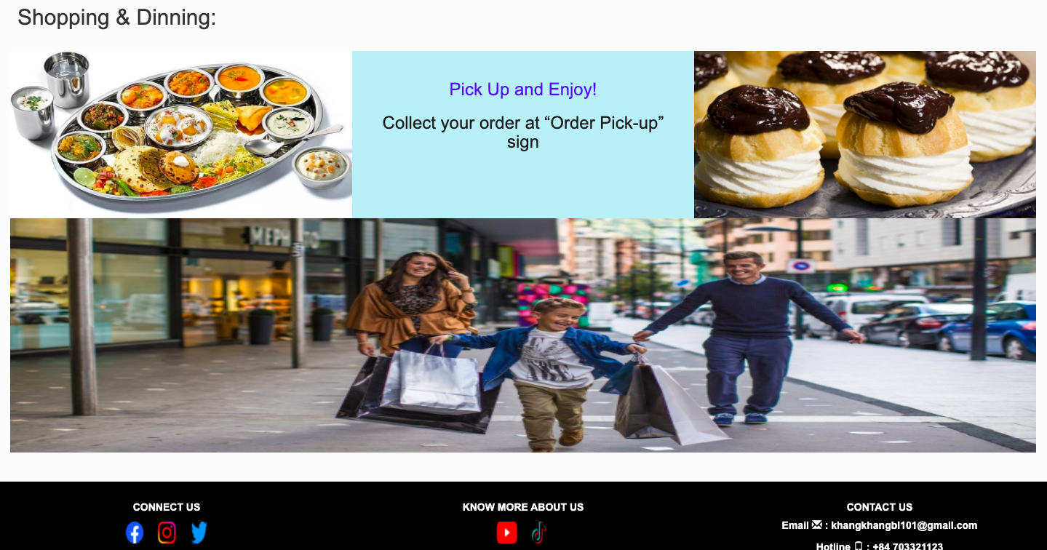

**5.Leisure &dinning page:**

Description:This webpage displays following information: Display about food, hotel, some product and their infomation,price.

Screen shot:

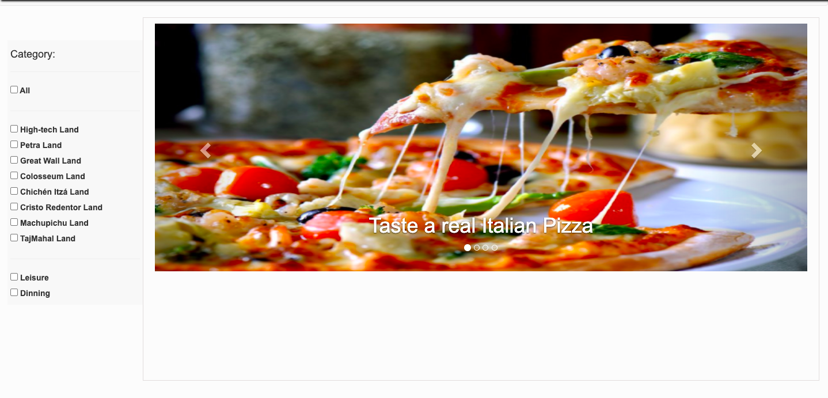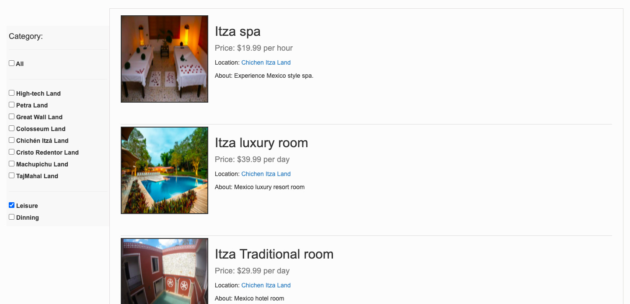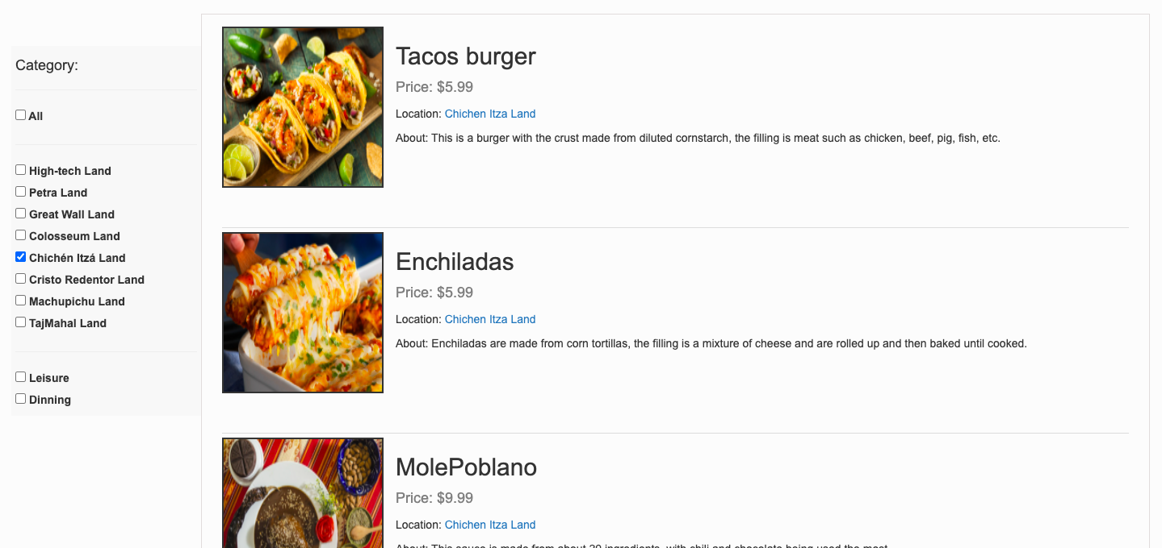

**6.Contact us+business opportunities page:**

Description:This webpage displays following information: Display about some infomation, question and answers, form apply job, email, phone number,address, map and comment box.

Screen shot:

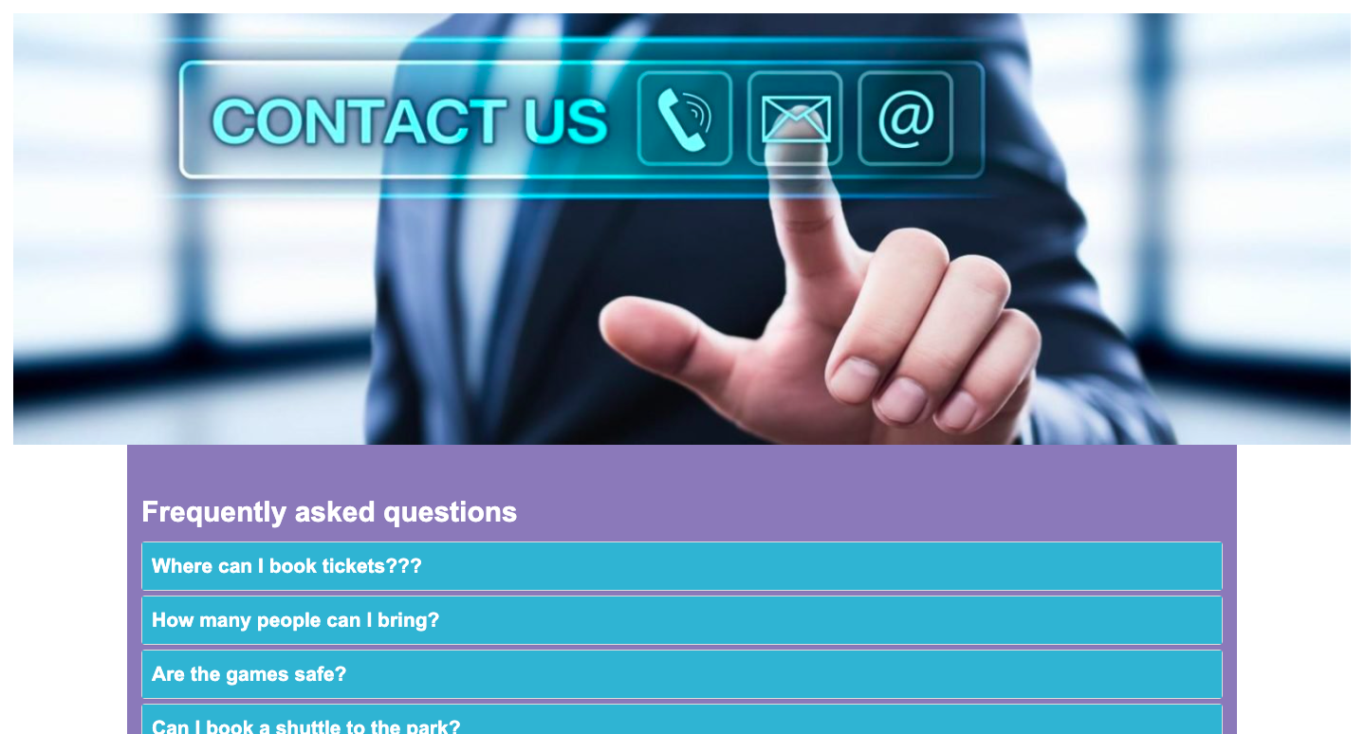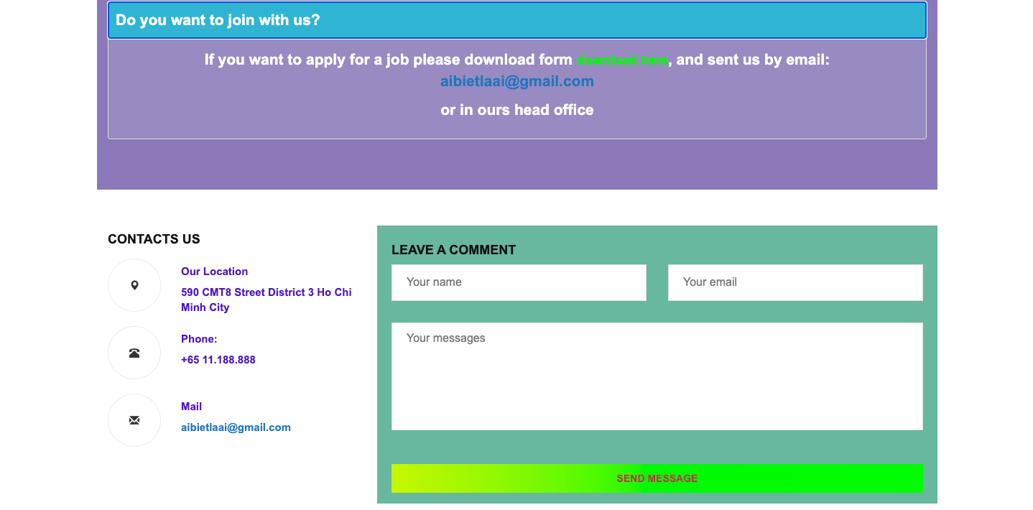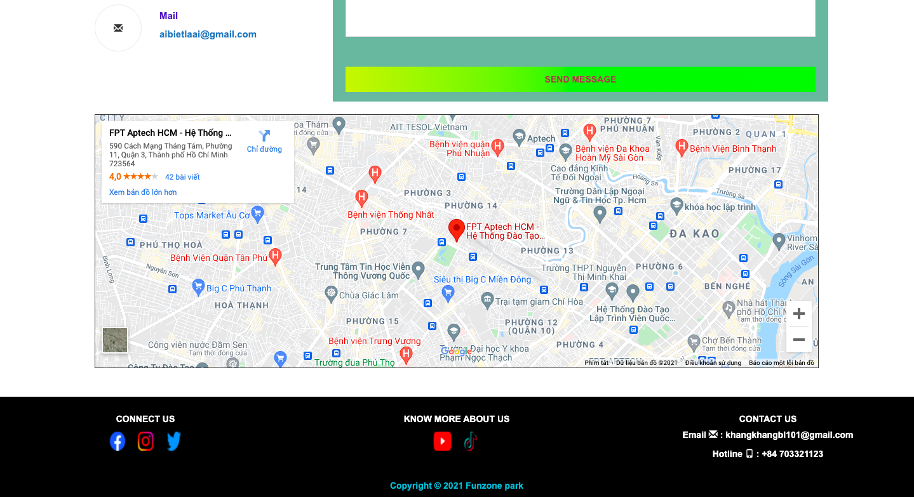

**7.About us page(Team infomation page)**

Description:This webpage displays following information: display infomation of eproject team member.

Screen shot:

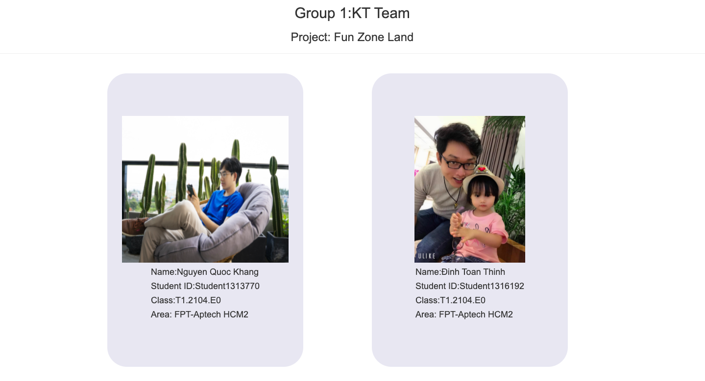

**8.Menu &footer**

Description:This webpage displays following information:

Menu:display link of section in web:  
What up page,

Experience page(8 page of 8 section)

LOGO-link: home page

Leisure & Dinning page

About us page- Contact us page( bussiness opportunities).

Footer: display:

Copyright, develop-team

Icon-link of funzone(social network-facebook,instagram,twiter,youtube,tiktok)

Email and hot-line for customer service.

Screen shot:



**9.Javascript**

1. **This script is using show img and information when hover in list name of sections in experience page. It is implemented with the support of the Jquery library. And a script is using show the picture in fullscreen mode in Experience page.**

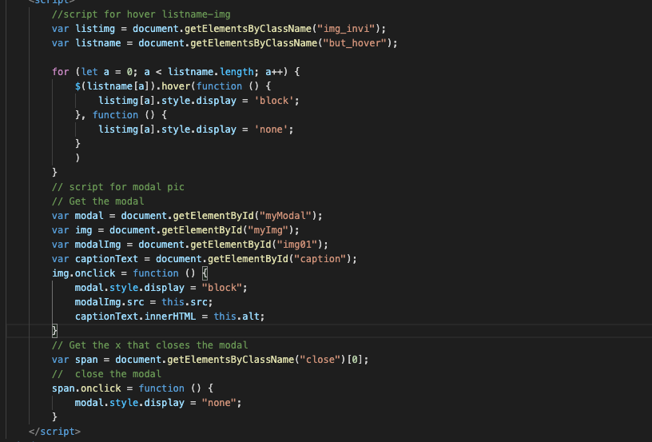

1. **This script is using show count down a time event start in what up page.**

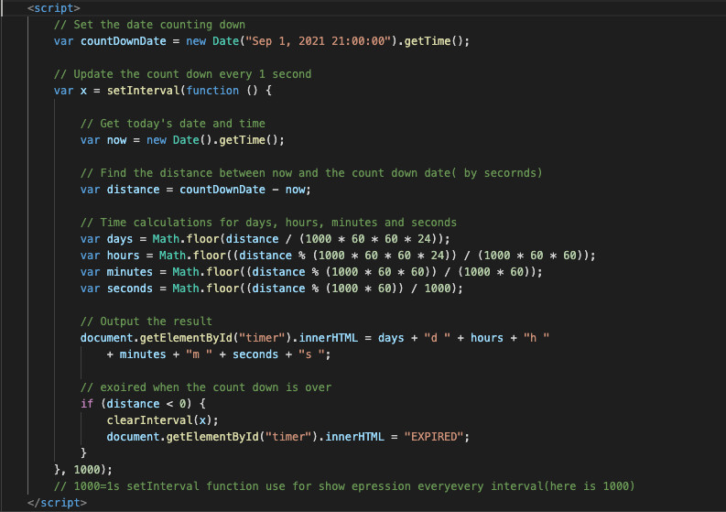

1. **script use for auto play, play and pause video in home page**

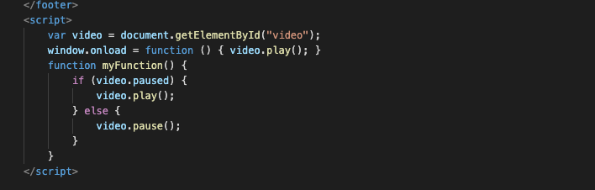

1. **script use for animation in hightechland page**

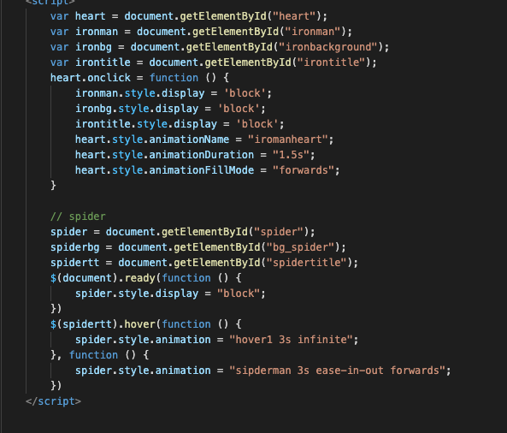

1. **script use for filter product in leisure and dinning page :8 section and 2 kind of product( leisure-dinning).**

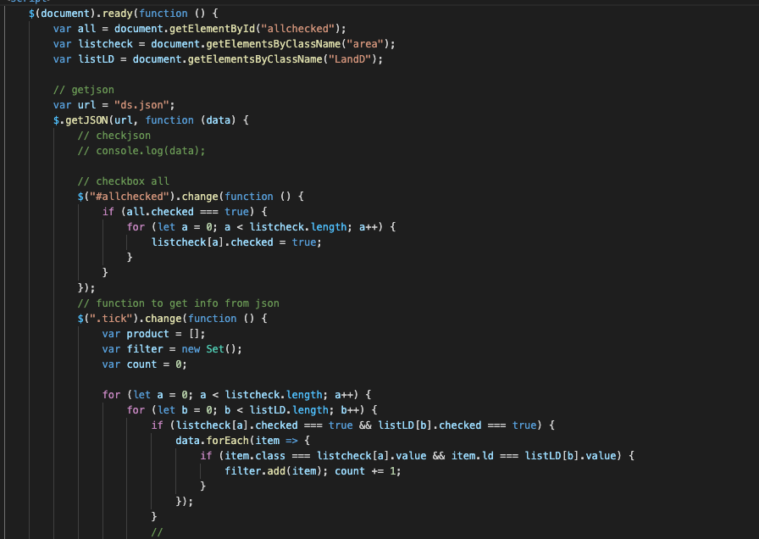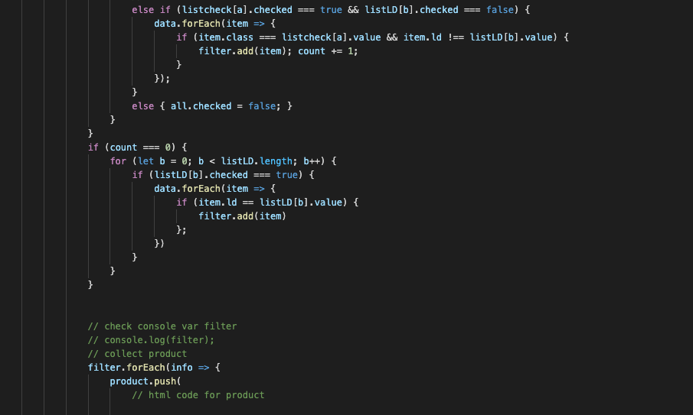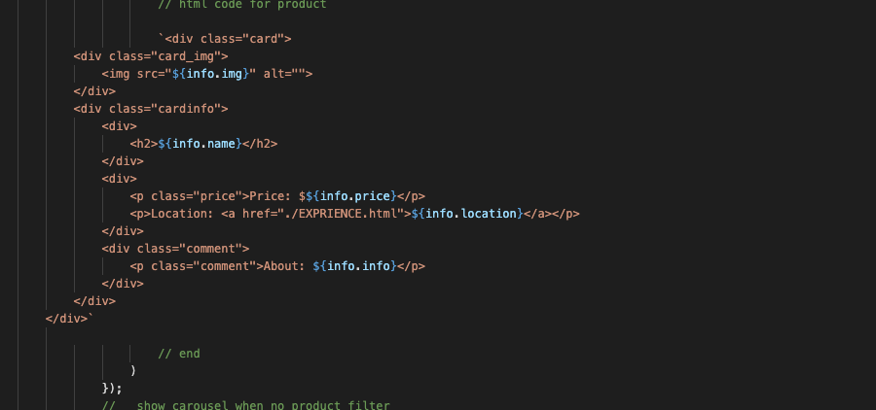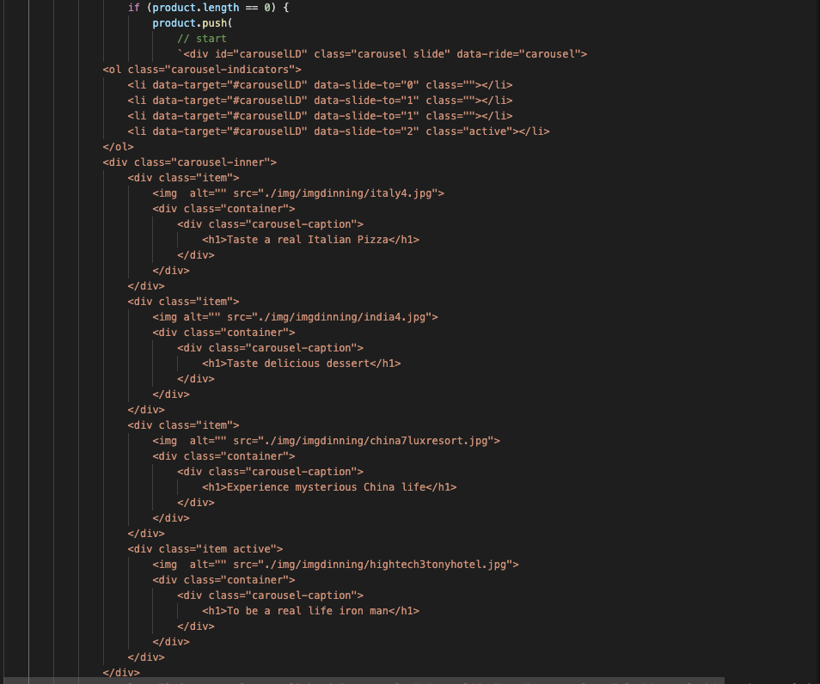

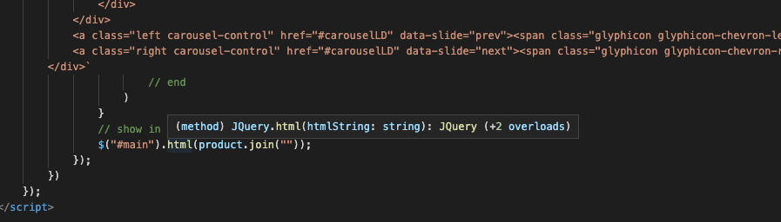

1. **Json for Leisure and dinning page.**

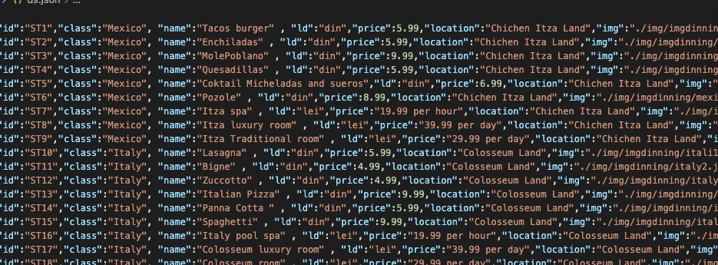

1. **script for toggle img infomation in 7 - wonder page.** 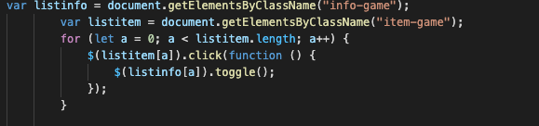

# TASK SHEET REVIEW 3

|  |  |  |  |  |  |  |  |
| --- | --- | --- | --- | --- | --- | --- | --- |
| ***Project Ref. No.:***  ***eP/Advertisement Portal Management System/01*** | | ***Project Title:*** | ***Activity Plan Prepared By:*** | ***Date of Preparation of Activity Plan:*** | | | |
| ***Sr.***  ***No.*** | ***Task*** | ***Actual Start***  ***Date*** | ***Actual Days*** | ***Team Mate***  ***Names*** | ***Status*** |
| *1* | *Home page* | *Funzone* | *Nguyễn Quốc Khang* | *25-07-2021* | *3* | *Khang* | *Completed* |
| *2* | *Experience page* | *17-07-2021* | *1* | *Khang* | *Completed* |
| *3* | *Whatup page* | *18-07-2021* | *3* | *Khang* | *Completed* |
| *4* | *Highland Park Character page* | *03-08-2021* | *2* | *Khang* | *Completed* |
| *5* | *7 wonder Park character page* | *17-07-2021* | *10* | *Thịnh* | *Completed* |
| *6* | *Dinning-leisure page* | *01-08-2021* | *2* | *Khang* | *Completed* |
| *7* | *About us page* | *05-08-2021* | *1* | *Khang* | *Completed* |
| *8* | *Contact us page* | *01-08-2021* | *1* | *Thinh* | *Completed* |
| *9* | *Javascrip* |  |  | *17-07-2021* | *20* | *Khang* | *Completed* |
| *10* | *Check & fix code* |  |  | 05-06-2021 | *7* | *Khang +*  *Thịnh* | *Completed* |
| *11* |  |  |  |  |  |  |  |
| *12* |  |  |  |  |  |  |  |
| *13* |  |  |  |  |  |  |  |

|  |  |
| --- | --- |
| **Date: 05-08-2021** | |
| Signature of Instructor:  **Ms. Le Mong Thuy** | Signature of Team Leader:  **Nguyễn Quốc Khang** |